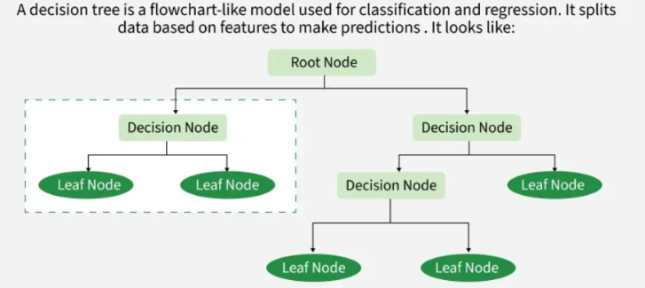
Decision trees

Information gain
Information Gain tells us how useful a question (or feature) is for splitting data into groups. It measures how much the uncertainty decreases after the split.

Entropy- It is the measure of uncertainty of a random variable.
it characterizes the impurity of an arbitrary collection of examples.
Given a certain set of events that occur with probabilities $\left(p_{1},p_{2},…,p_{n}\right)$, the total entropy $H$ can be written as the negative sum of weighted probabilities:
$$H=-\sum_{i=1}^{n}{p_{i}}{log⁡}_{2}(p_{i})$$

Entropy Properties
- $H=0$ only if all but one of the $p_{i}$ are zero, this one having the value of 1. Thus the entropy vanishes only when there is no uncertainty in the outcome, meaning that the sample is completely unsurprising.
- $H$ is maximum when all the $p_{i}$ are equal. This is the most uncertain, or 'impure', situation.
- Any change towards the equalization of the probabilities $\left(p_{1},p_{2},…,p_{n}\right)$ increases $H$.

Information gain
Information Gain tells us how useful a question (or feature) is for splitting data into groups. It measures how much the uncertainty decreases after the split.
$$\text{Gain}\left(S,A\right)=\text{Entropy}\left(S\right)-\sum_{v∈\text{Values}\left(A\right)}{\frac{\left|S_{v}\right|}{\left|S\right|}}\text{Entropy}\left(S_{v}\right)$$

Gini index:
measures the impurity of a node in a decision tree.
$$\text{Gini}=1-\sum_{i=1}^{n}{{\left(p_{i}\right)}^{2}}$$
The Gini Index is faster to compute than Entropy.

- Decision trees are non-parametric methods where the number of parameters depends solely on the data set on which training is carried out.

- decision trees take categorical and numerical (continuous) inputs

- Decision trees adapt their output based on the target variable: they perform classification for categorical labels and regression for continuous numerical values.

Why its suitable for edge?
- Low computational overhead- Inference involves simple if-else which requires negligible CPU and RAM.
- Minimal latency because theres no complex computing and just a few simple comparisons.
- No specialized hardware like a GPU or NPU is required as it can run efficiently on low power CPUs.
- The entire model structure occupies very little storage, which is critical for devices with restricted memory capacity.
- No network dependency, runs entirely on device.

